NAME :- VARSHITHA M S
TASK – 01

1. Employee ID generator....
- static Variable: company_name, employee_count
- Instance Variables: employee_name, department
- Local Variable: employee_id (created inside generate_employee_id())
- Constructor: __init__()
- Instance Method: generate_employee_id()
- Objects: emp1, emp2, emp3
Solution:-
class EmployeeID:
employee_count = 1000
company_name="Kaizentrix Global Solutions"

def __init__(self,n,d):
self.name=n
self.department=d

def generate_employee_id(self):
EmployeeID.employee_count+=1
employee="EMPKGS"+str(EmployeeID.employee_count)
return employee

print("=====================Welcome to employee ID generator=======================")
number=int(input("Enter the number of employee you want to generate ID's: "))

for i in range(1,number+1):
n=input("Enter the employee name: ")
d=input("Enter the employee department: ")

print("--"*30)
f1=EmployeeID(n,d)

print("Employee details....")
print("Company name: ",EmployeeID.company_name)
print("Employee Name: ",f1.name)
print("Employee Department: ",f1.department)
print("Employee ID: ",f1.generate_employee_id())
print("===="*30)

Output:-
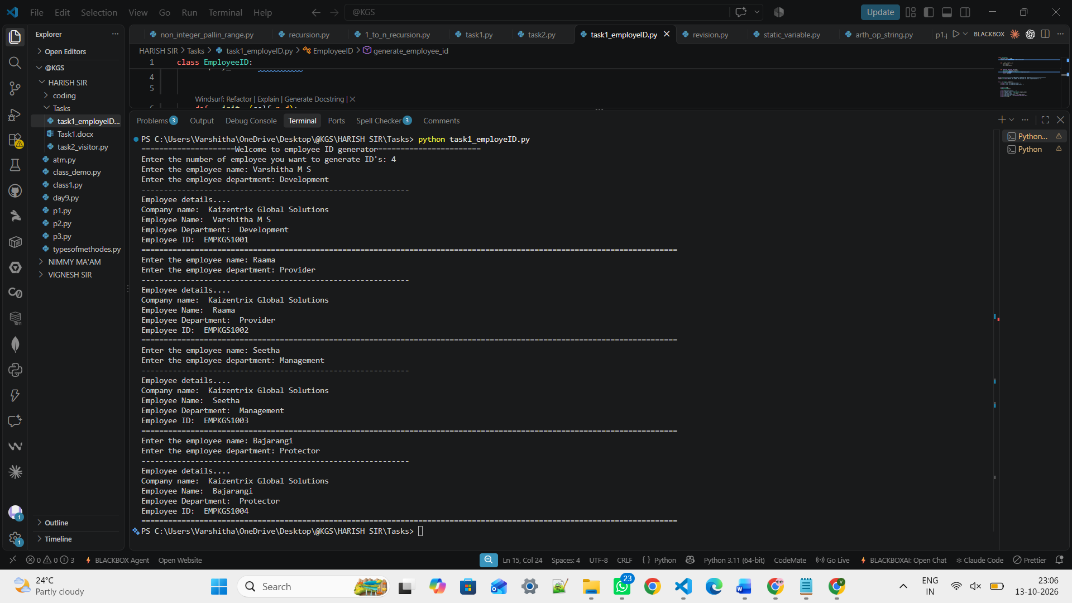

2. Introduction: Corporate Visitor Management System (VMS)
The Corporate Visitor Management System (VMS) is a Python-based application developed to manage visitor entry and exit in an organization. It collects visitor details, records entry and exit times, calculates visit duration, and displays visitor guidelines. This project uses Object-Oriented Programming (OOP) concepts such as classes, objects, instance methods, static methods, instance variables, and local variables to simplify and organize visitor management at Kaizentrix Global Solutions.
Solution:-

class visitorManagementSystem:
company = "Kaizentrix Global Solutions"

def __init__(self): #here i created the properties which need to be stored in heap since if should be initially present before assigning any values to it
#If not initialized the properties here you will get an attribute error bcz outside visitor check in during the check out we cannot use it
#Bcz pvm ended up executing a method activation response holding these variables will be deleted
self.id = ""
self.name = ""
self.mob_no = ""
self.to_meet = ""
self.department = ""
self.purpose = ""
self.entry_time = 0 #entry time starts from zero
self.exit_time = None # none--> nothing we cannot consider the exit time before we check in that is before entry time
self.checked_in = False #make check in false bcz the we are not sure that user will check in, they may check guidelines also

def visitorCheckIn(self, id, name, mob, meet, department, purpose, entry_time):
self.id = id
self.name = name
self.mob_no = mob
self.to_meet = meet
self.department = department
self.purpose = purpose
self.entry_time = entry_time
self.checked_in = True

print("\nVisitor checked in successfully!")
print("Welcome,", self.name)

def visitorCheckOut(self, exit_time):
if not self.checked_in:
print("Please check in first.")
return

self.exit_time = exit_time
duration = self.exit_time - self.entry_time

print("\n======= Visitor Summary =======")
print("Visitor ID :", self.id)
print("Visitor Name :", self.name)
print("Company :", self.company)
print("Mobile :", self.mob_no)
print("Person to Meet :", self.to_meet)
print("Department :", self.department)
print("Purpose :", self.purpose)
print("Entry Time :", self.entry_time)
print("Exit Time :", self.exit_time)
print("Visit Duration :", duration, "Hours")

self.checked_in = False
print("\nVisit completed successfully!")
print("Thank you. Visit again!")

def visitorGuidelines(self):
print("\n======= Visitor Guidelines =======")
print("1. Wear your Visitor ID Card.")
print("2. Photography and videography is not allowed.")
print("3. Follow company security rules.")
print("4. Smoking and drinking alcohol is prohibited.")
print("5. Collect your visitor card for the valid visit.")
print("6. Return your Visitor Pass before leaving.")
print("7. Report to Reception while exiting.")
print("8. Use dustbins and help us for clean environment.")
print("===="*30)

print("****"*40)
print("KAIZENTRIX GLOBAL SOLUTIONS")
print("Corporate visitor management system")
print("****"*40)

f1 = visitorManagementSystem()

while True: #While true it should ask every time the choices whether the visitor will proceed with any of the choices

print("\n1. Visitor Check-In \n2. Visitor Check-Out \n3. Visitor Guidelines \n4. Exit")
choice = input("Enter your choice: ")

if choice == "1":
id = input("Enter your Visitor ID: ")
name = input("Enter your name: ")
mob = input("Enter your mobile number: ")
meet = input("Enter the person you want to meet: ")
department = input("Enter the department: ")
purpose = input("Enter the purpose of your visit: ")
entry_time = int(input("Enter entry time (0-23): "))

if entry_time < 0 or entry_time > 23:
print("Invalid entry time.")
continue

f1.visitorCheckIn(id, name, mob, meet,department, purpose, entry_time) #call the check-in method with the reference variable of the object/class

elif choice == "2":
if not f1.checked_in: #Sandhya ma'am told no need but without checking in how user can checkout..?
print("Please check in first.")
continue

while True:
exit_time = int(input("Enter exit time (0-23): "))

if exit_time < 0 or exit_time > 23 or exit_time<f1.entry_time: #Like visitor should enter the valid exit time that is between 0 to 23 and they cannot exit before they actually checked in time
print("Invalid exit time.")
continue
f1.visitorCheckOut(exit_time) #Go for visitor checkout method and execute the provided code
break

elif choice == "3":
f1.visitorGuidelines()

elif choice == "4":
print("Thank you for using KGS Visitor Management System.")
break

else:
print("Invalid choice. Please select the option among 1,2,3,4.")
Output:-****************************************************************************************************************************************************************
KAIZENTRIX GLOBAL SOLUTIONS
Corporate visitor management system
****************************************************************************************************************************************************************

1. Visitor Check-In
2. Visitor Check-Out
3. Visitor Guidelines
4. Exit
Enter your choice: 2
Please check in first.

1. Visitor Check-In
2. Visitor Check-Out
3. Visitor Guidelines
4. Exit
Enter your choice: 1
Enter your Visitor ID: VSIT1021
Enter your name: Varshitha M S
Enter your mobile number: 7022151145
Enter the person you want to meet: Raama
Enter the department: H R
Enter the purpose of your visit: Interview
Enter entry time (0-23): 11

Visitor checked in successfully!
Welcome, Varshitha M S

1. Visitor Check-In
2. Visitor Check-Out
3. Visitor Guidelines
4. Exit
Enter your choice: 2
Enter exit time (0-23): 5
Invalid exit time.
Enter exit time (0-23): 15

======= Visitor Summary =======
Visitor ID : VSIT1021
Visitor Name : Varshitha M S
Company : Kaizentrix Global Solutions
Mobile : 7022151145
Person to Meet : Raama
Department : H R
Purpose : Interview
Entry Time : 11
Exit Time : 15
Visit Duration : 4 Hours

Visit completed successfully!
Thank you. Visit again!

1. Visitor Check-In
2. Visitor Check-Out
3. Visitor Guidelines
4. Exit
Enter your choice: 3

======= Visitor Guidelines =======
1. Wear your Visitor ID Card.
2. Photography and videography is not allowed.
3. Follow company security rules.
4. Smoking and drinking alcohol is prohibited.
5. Collect your visitor card for the valid visit.
6. Return your Visitor Pass before leaving.
7. Report to Reception while exiting.
8. Use dustbins and help us for clean environment.
========================================================================================================================

1. Visitor Check-In
2. Visitor Check-Out
3. Visitor Guidelines
4. Exit
Enter your choice: 4
Thank you for using KGS Visitor Management System.

